**SE 339 Software Architecture and Design**

**Final Exam, Spring 2021**

Dr. Lotfi ben Othmane

Name: Chimzim Ogbondah

ID: 273362113

# Directions

* This is a take-home exam. Each student must work independently—this is not group work.
* This exam is open-book, open-note, and open-laptop.
* Your answers need to be precise and clear.
* Type your answers in the word document and submit your document as a pdf file.

**Section 1**

**Question 1.1** (10 pts): Why automated recovery of software has limited capabilities?

* By Nature because code is just a fragment of the architecture and it is challenging to identify the use cases just from the software in a good way

**Question 1.2** (10 pts): What problem does the adaptor architecture pattern solve? How does it solve it?

* It solves imcopatibility between different components and it solves it by creating an interface the will work for different components and the system

**Question 1.3** (10 pts): Enumerate three ways to implement the plugins patterns and give an example of the use of each of them.

* Browser Plug-ins: Cisco offering a view of a video structure from google chrome
* Scripts: Tracking mouse movements for an app
* Abstract files: File Storage

**Question 1.4** (10 pts): Enumerate five factors that impact the level of details of architecture documentation.

* Complexity of the software
* Longevity of the software
* Who the stakeholders are
* Time
* Budget

**Question 1.5** (10 pts):

Why companies sometimes decide to evaluate the architecture of a given software?

* Companies might evaluate a given software if they plan to buy the system or to see how the architecture is

**Section 2**

Assume that your company developed a prototype of a fleet management system. The following figures depict the architecture of your software. Figure 1 shows the component diagram of the prototype. The system comprises three microservices (similar to the microservices of assignment 3) and a component for collecting data from the vehicle called "dataCollector." Figure 2 shows three microservices and the “DataCollector” component. The microservices are deployed to a server, and the other component is deployed to a client host, a Raspberry PI. Figure 3 shows a communication diagram of the use case "Get data" from the vehicle periodically." The simulator in Figure 3 plays the role of a vehicle that regularly sends data about the fuel level, speed, RPM, direction, etc., to the "Usage microservice." The microservices are developed using Spring Boot, and the “dataCollector” component is developed using Python.

|  |  |
| --- | --- |
|  |  |
| Figure 1: Component diagram. | Figure 2: Deployment diagram. |

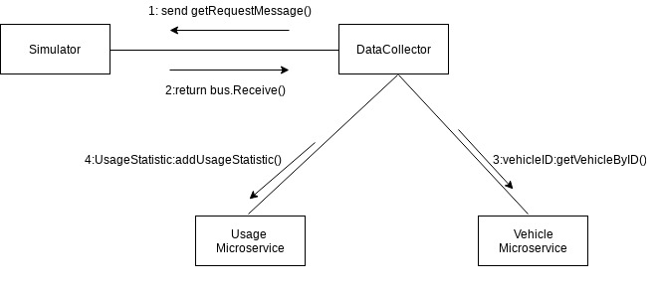

Figure 3: Communication Diagram for the use case "get data" from the vehicle periodically.

Your task is to design a revision of the architecture (Architecture version 2) for a usable product out of the prototype that you have. The architecture shall address the following NEW architecture drivers:

UC-1: A user can use the system to view the location of a given vehicle on a Google map.

UC-2: A user can use the system to view the speed, RPM, and fuel level of a given vehicle.

QA1- It is expected to serve one thousand (1000) vehicles simultaneously, and each vehicle sends its data in one message every 1 minute. The expected average processing of a message is ten milliseconds. The system must not lose data coming from the vehicles.

**Question 2.1** (10 pts): Develop a context diagram for the system. which shall consider the existing system and the new architecture drivers.

**Question 2.2** (10 pts): What architecture pattern shall you use to address QA1?

* Queue management can solve this problem since the rate at which vehicles send their message will be high than the rate at which it can process the requests. We can also use the Master-Slave pattern to be able to service each of the requests.

**Question 2.3** (20 pts): Update the component diagram to support the new architecture drivers—You shall consider your answer to Question 2.2.

Assumptions: The microservices will be configured to support the **Master-Slave** pattern so things can continuously be serviced off the queue. Also asumming that the software will now support the use of Google Maps API and in vehicle collection the GPS position is sent.

**Question 2.4** (10 pts): Develop a communication diagram for use case 2 (a user can use the system to view the speed, RPM, and fuel level of a given vehicle).

Assumptions: The data is returned to the user based off the vehicle ID they provided